FOR IMMEDIATE RELEASE

# Hoffmann Architects + Engineers Announces Promotions

## Hoffmann Architects + Engineers Promotes Guilherme C. Pinho, Senada Dushaj, Jeremiah O. Ekoja, and Mike F. Criollo Lalvay

*New Haven, Conn. — 12 Dec 2024 —* Hoffmann Architects + Engineers, an architecture and engineering firm specializing in the rehabilitation of building exteriors, is pleased to announce that Guilherme Pinho, Senada Dushaj, Jeremiah O. Ekoja, and Mike F. Criollo Lalvay have recently earned promotions.

**Guilherme C. Pinho,** an exceptional member of Hoffmann’s Connecticut team, has been promoted to Project Manager. His promotion reflects his expertise in managing complex building envelope rehabilitation projects. Since joining Hoffmann in 2019, Pinho has demonstrated his ability to provide investigation, design, and construction administration for a wide variety of projects, with a particular focus on historic preservation. The most notable projects under his leadership include overseeing the facade restoration of Vassar’s Main Building, providing historical consulting for The U.S. Military Academy at West Point, and several roof replacement projects at Collins Aerospace.

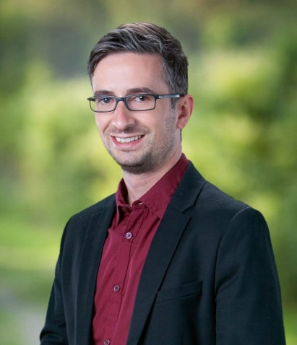

*Guilherme C. Pinho*

Pinho earned his Bachelor of Architectural Engineering Technology Degree from University of Hartford. He then went on to complete an expedited Master of Architecture program at Boston Architecture College while working full time at Hoffmann. Dedicated to sustainability, Guilherme is designing and hand-building his own zero-carbon Passive House, embodying his commitment to eco-conscious living and proving that sustainable design is more than a principle, it’s his way of life.

Pinho is a founding member of Hoffmann’s Diversity and Inclusion Committee in which his efforts helped launch the Diversity and Inclusion Blog. He is also an associate member of AIA and a member of the CT AIA J.E.D.I. Committee.

**Senada Dushaj**, of the firm’s New Haven, Conn. team, has been promoted to Project Coordinator. Dushaj joined Hoffmann in 2021 as Project Representative and was promoted to Senior Project Representative shortly thereafter, showcasing her dedication and expanding expertise. She has worked on numerous projects, demonstrating her knowledge and expertise in roof repairs and replacements, window replacements, facade rehabilitations, plaza renovations, and building envelope assessments.

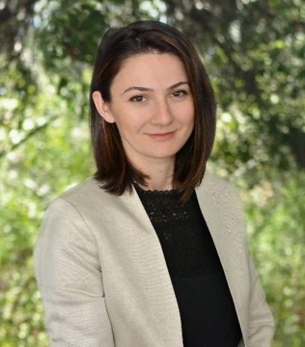

*Senada Dushaj*

Dushaj is currently serving as the team lead on the Irwin House project in New Canaan, Conn., where she is performing a condition assessment of the facades, low-slope and slate roofs for the town-owned property that was once the country home of Thomas J. Watson, former CEO of IBM. She has also spearheaded several rehabilitation projects for Aetna buildings in Hartford, specifically the Rogers Building, which included repairs to limestone facade units, removal of elastomeric coating, repair of spalled elements, and application of new mineral silicate stain.

Dushaj holds a Bachelor of Architecture from Keene State College and a Master of Architecture from the University of Massachusetts Amherst. In addition to her project work, she actively contributes to the firm’s professional development initiatives. This year alone, she’s hosted a variety of “Lunch and Learns” with subject-matter experts, including sessions on TPO roofing systems, integral crystalline waterproofing, fluid-applied roofing, and solar cladding. She is also a member of the Emerging Professionals Committee, further underscoring her drive for growth.

**Jeremiah O. Ekoja**, LEED Green Associate, member of the Washington D.C. team,has been promoted to Senior Project Representative. Over the past two years, Ekoja has played a pivotal role in a variety of projects. His contributions span the entire project lifecycle, from engaging in client meetings to serving as a primary point of contact during the construction phase, all while ensuring seamless project execution.

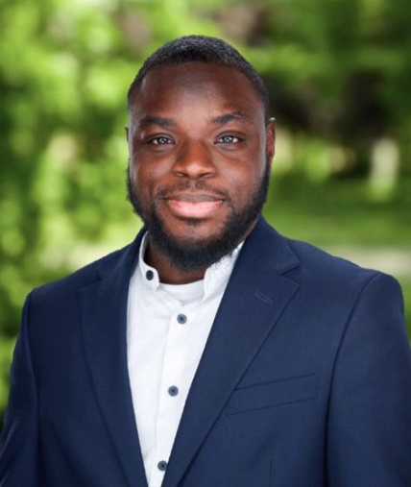

*Jeremiah O. Ekoja*

Ekoja played a key role in the facade inspection of 10 Verizon buildings in New York and New Jersey. Each of these buildings required careful observation and denotation in surveying the safety of several Verizon building exteriors. Along with the successful execution of window investigations, building envelope design services, and roof condition assessments, he performed a water infiltration investigation for the National Museum of the American Indian Cultural Resource Center of the Smithsonian Institution. Ekoja’s work for Smithsonian building does not end there, he has also prepared a window survey and investigation for the National Museum of American History. His valuable contributions to Smithsonian buildings demonstrate his proficiency in rehabilitating monumental structures.

With a Bachelor of Science in Architectural and Environmental Design as well as a Master of Architecture from Morgan State University, Ekoja has demonstrated a passion for design. His appreciation for great architectural buildings and historical landmarks drives his aspiration to contribute to the monuments that shape society. Ekoja has organized events through Hoffmann’s Book and Film Club to help promote discussions that foster inclusivity within the firm. Additionally, his involvement with the Emerging Professionals Committee showcases his commitment to mentorship and professional development.

**Mike F. Criollo Lalvay** has been promoted to Project Coordinator. Since joining the firm in 2021, Criollo Lalvay has provided engineering support for facade work, roof replacements, parking garage inspections, remedial design improvements, structural enhancements, and condition assessments including NYC Facade Inspection Safety Program (FISP) investigations.

Criollo Lalvay has played a key role in many projects, among them, the Scholastic Inc. Headquarters sidewalk vault rehabilitation, a comprehensive facade investigation for the Church of Scientology, and a parking garage inspection for Hines Interests Limited Partnership. For these projects, Criollo Lalvay devoted his skills and expertise in preparing condition assessment and survey reports, performing field work, coordinating with building management, clients, and contractors, producing construction drawings, and diligent oversight of the projects overall.

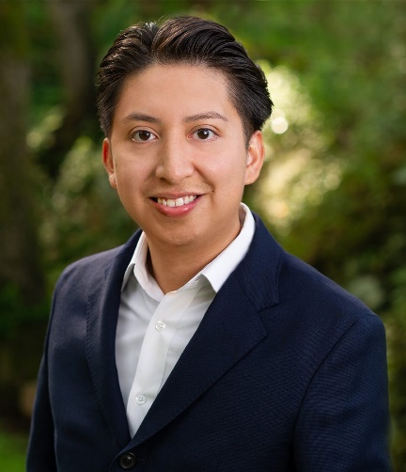

*Mike F. Criollo Lalvay*

He obtained his Bachelor of Civil Engineering from Cornell University and an Associate of Engineering Science from Westchester Community College. As an integral member of the Emerging Professionals Committee, Criollo Lalvay actively fosters camaraderie and celebrates team successes, enhancing Hoffmann’s workplace culture.

Founded in 1977, Hoffmann Architects + Engineers specializes in the rehabilitation of the building enclosure. The firm’s work focuses on the exteriors of existing structures, diagnosing and resolving deterioration within facades, roofing systems, windows, waterproofing materials, plazas/terraces, parking garages, and historic and landmark structures. We provide consulting services for new building construction, as well as litigation and claim support. Our technical professionals investigate and correct damage resulting from time and weather, substandard or improper construction, design defects, material failures, poor workmanship, structural movement, and stress. To learn more, visit [www.hoffarch.com](http://www.hoffarch.com).